XSEDE New Research Allocation Renewal:

Harnessing cloud computing and genomics to facilitate adaptive species conservation of non-model organisms

Principal Investigator: Marlis R. Douglas

Co-Principal Investigator: Michael E. Douglas

Contributor: Tyler K. Chafin

*University of Arkansas Department of Biological Sciences, Fayetteville, AR 72701*

This research allocation proposal is a renewal request for the Jan-Dec 2018 period. Our lab has received two Startup allocations, and an XRAC for the Jan-Dec 2017 period (TG-BIO160065), as well as being one of the first to employ the Jetstream system during **the Early Operations phase** to produce publishable science (see Section 4 and Appendices). With the requested allocation renewal, we plan to expand these efforts by conducting multiple new collaborative efforts applying genomic data to species of conservation concern.

**Our objective is to facilitate applications of genomic approaches and new analytical approaches harnessing the Jetstream cloud system to promote collaboration between researchers with either bioinformatics or biodiversity expertise**. To this end, we propose several new collaborative projects between conservation agencies and the Douglas lab (see Section 2) utilizing the greatly enhanced productivity our lab has found in Jetstream over alternative HPC resources.

1. **Scientific Background**
   1. *Biodiversity Loss and Delineation of Conservation Units*

Accelerated loss of biodiversity is one of the fundamental issues in the Anthropocene [defined as current time period, with human activities dominating global ecosystem processes (Lewis & Maslin 2015)], with direct, potentially irreversible consequences for the well-being of humankind. **In order to protect biodiversity, the question ‘What should be conserved?**’ **must first be addressed** (Douglas & Brunner 2002). While delineation of conservation units would seemingly be a straight-forward process, it is in fact complicated by philosophical and methodological contentions. In part, this reflects an underlying conflict between traditional taxonomy, the highly codified, but slow process by which species are recognized and described, and contemporary conservation, with its immediate necessity to delineate biodiversity for implementation of management actions. This dilemma is further complicated by the different spatial and temporal scales the two disciplines operate under; species arose through historical processes over geologic time, whereas conservation deals with contemporary quandaries affecting local populations.

Recent advances in genomic (Next-Generation-Sequencing) and analytical (Coalescent and Bayesian modeling) approaches allow to circumvent some of the controversies by applying quantitative metrics to define ‘Conservation Units’ (Holycross & Douglas 2007; Sullivan *et al.* 2014) with the ultimate goal of delimitating adaptively divergent gene pools (Funk *et al.* 2012). However, analysis of genome-scale data within a hypotheses-testing framework presents a new set of computational challenges, magnified by limited bioinformatics skills among conservation practitioners.

**Conservation genetics, a multi-disciplinary science that uses molecular data to delineate biodiversity**, can bridge this gap. Genetic data can distinguish populations and parse differentiation at very fine spatial scales (e.g., Douglas *et al.* 1999, Hopken *et al.* 2013). At the same time, molecular data can provide a deep historical perspective and reveal causation of genetic patterns (e.g., Douglas et al. 2006, 2009). While this provides a mechanism to develop integrated regional conservation policies to manage biodiversity (Willis & Birks 2006), it presents a challenge in that translation of apparent genetic partitions into taxonomic classification (species descriptions) remains difficult (Carstens *et al.* 2013). Yet, resolving this discord is vital to protect biodiversity.

The immutability of traditional taxonomic approaches can be circumvented by applying more **adaptively defined ‘Conservation Units’** (Holycross & Douglas 2007; Sullivan *et al.* 2014) which **describe biodiversity through quantitative metrics** (Moritz 1994; Vogler *et al.* 1994). The goal of such delimitations is ultimately to define adaptively divergent gene pools, and next-generation sequencing approaches are ideal, because they facilitate integration of thousands of genomic loci, that span the gamut of evolutionary processes (Funk *et al.* 2012).

* 1. *RAD-sequencing and Conservation Units*

The advent of flexible, reduced-representation genomic methods has the potential to **revolutionize conservation genetics by making genomic data affordably attainable for studies involving non-model organisms** (i.e., most natural populations of conservation concern). Reduced-representation libraries (RRLs) randomly target loci distributed throughout the genome, but in a way such that recovered loci are largely congruent (homologous) across appropriate phylogenetic scales (within or among closely-related species).

This is most commonly accomplished through RAD-sequencing approaches (restriction-site associated DNA: Figure 1), where genomic complexity is curtailed by targeted fragmentation using restriction enzymes that ‘cut’ genomic DNA at a predictable sequence motif (e.g. CTGCAG). This approach ensures consistency across individuals, making it applicable to organisms for which no *a priori* knowledge of genome composition is available. Methodological iterations of the original RAD protocol (Baird *et al.* 2008) have been remarkably prolific, spawning multiple derivatives that extend applicability to particular research foci (e.g. Peterson *et al.* 2012; Ali *et al.* 2015), although the ubiquitous objective of these approaches remains consistent – **subsampling genomic information consistently across individuals**. Additionally, software pipelines for RADseq assembly (e.g. Catchen *et al.* 2013; Eaton 2014) have expanded access for molecular ecologists and conservation geneticists with limited bioinformatics expertise.

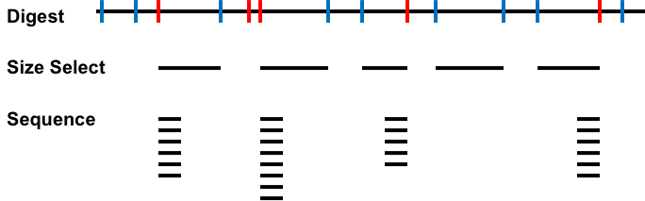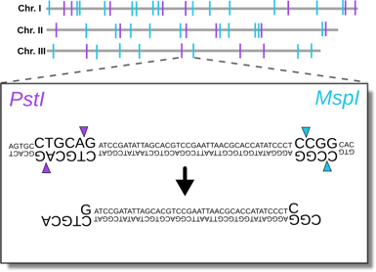

**Double Digest Restriction-Site Associated DNA Sequencing**

**Figure 1**. ddRADseq is a reduced-representation library approach that subsamples genomic loci consistently across individuals, making making genomic data affordably attainable for studies involving non-model organisms. From Chafin *et al*., unpublished.

* 1. *Analytical Framework To Delineate Conservation Units*

However, combining next-generation sequencing with traditional methods of biodiversity assessment presents a new set of challenges, in that **no pre-existing analytical framework** is appropriate. For example, to account for heterogeneity in the coalescent (evolutionary) process, information of many, often thousands of independent genomic loci must be simultaneously integrated, while considering how concordance among gene trees reflects the ‘true’ evolutionary pattern. Inferences based on individual loci are often discordant (Figure 2) - possibly due to incomplete lineage sorting (stemming from insufficient time since divergence and retention of ancestral polymorphism) or *post hoc* phylogenetic reticulation (introgression among lineages on independent, evolutionary trajectories).

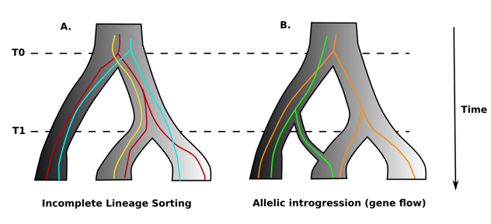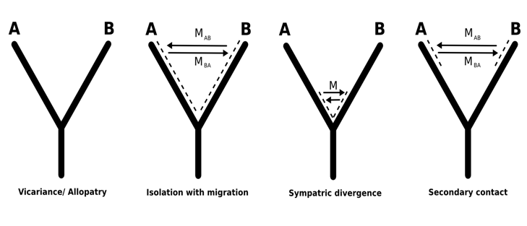

**Figure 2**. Various evolutionary processes are driving diversification of organisms, yielding discordant gene trees when thousands of genomic loci are analyzed. From Chafin *et al*., unpublished.

In simple terms, assuming a species relationship of (((A,B), C), D) – where parenthesis indicate that species A and B are most similar, with D being most distinct. Some genes - whether reflecting inherent stochasticity of the coalescent process, or gene flow between species - may show a topology of (((A,C),B),D). This problem, termed ‘gene tree discordance’, can be statistically evaluated using coalescent theory, by modeling the probabilities that gene tree topologies differ from the true branching pattern of the populations or species from which they were derived. Recent applications of the multispecies coalescent allow for the quantification of boundaries separating apparent genetic clusters - presumably intraspecific units - yet provide a naïve approach to taxonomic-decision making when implemented alone (Huang & Knowles 2016).

1. **Research Objectives**

**In multiple, collaborative efforts we will apply genomic data to species of conservation concern** to: 1) Evaluate proposed taxonomic changes and conservation action; 2) Investigate ‘blurring’ of species boundaries in association with anthropogenic habitat degredation; 3) Enhance management action to control wildlife disease spread; 4) Inform responsive economic development

**The studies outlined below form the foundation for several doctoral dissertations**. Graduate students working on these projects will be trained in both bioinformatics and applied conservation research, but also gain experience in working with collaborators representing various levels of expertise. Each study is expected to result in several peer-reviewed publications in journals such as *Molecular Ecology*, *Systematic Biology*, or *Evolution*. Objectives 1 and 2 are a continuation of work initiated during our Early Operations usage and 2017 XRAC (TG-BIO160065).

*2.1: Biodiversity delimitation and ‘the species conundrum’: quantifying genetic delineators*

Water and fishes and in the arid western North America are entangled with economic, political and cultural issues (Reisner 1986). The region harbors endemic fishes uniquely diversified to cope with the historically harsh and erratic conditions of desert rivers (Douglas *et al*. 1999). The effectiveness of these adaptations is diminished by rapid and large-scale alterations of water ability and flow regimes. A prolonged drought has exacerbated the situation – an apt example how climate change might accelerate the extinction vortex (Gilpen & Soule 1986). **Delimitation of remaining biodiversity is warranted for effective, region-wide conservation efforts.**

One wide-ranging western fish that lends itself well to a phylogeographic study of biodiversity in western river basins is *Rhinichthys osculus* – a species complex of small minnows generally referred to as Speckled Dace (Figure 3). It is still abundant and displays great morphological diversity, with many phylogenetic clades apparent at the sub-drainage level (e.g. Smith & Dowling 2008; Billman *et al.* 2010), presumably a result of the complex patterns of isolation and connection among drainages, and climate oscillations that molded western landscapes (Minckley 1986).

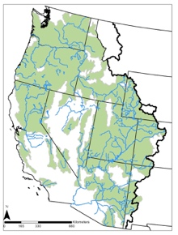 **A B C D**

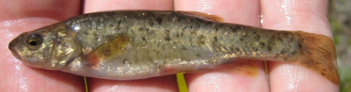

**Figure 3**. The Speckled Dace (*Rhinichthys osculus*), a small minnow (A), is the only fish native to all Western drainages (B). A phylogeny based on ~18,000 concatenated SNPs (C) revealed distinct clades associated with major drainages (D). From Mussmann *et al*., unpublished.

However, the high phenotypic variability observed in this minnow has led to taxonomic confusion, with many subspecies being described, and some not formally recognized (i.e., undescribed species). Many of these are in dire need of conservation actions to preserve swiftly dwindling populations (Ardren *et al.* 2010; Hoekzema & Sidlauskas 2014) – but these cannot be implemented without formal recognition of conservation units. Phylogenetic analyses reflected strong divergence among clades of *Rhinichthys spp.*( Oakey *et al.* 2004), yet to conclusively resolve species delimitations additional data are required. **We will apply coalescent-based species delimitation to resolve conservation units** (i.e., species or distinct population segments) in *Rhinichthys*. **Results will inform natural resource agencies and policy makers in devising regional plans for biodiversity conservation.**

*2.2: Introgression in endangered fishes and species boundary uncertainty*

Fishes of the genus *Gila* likewise exhibit morphological extremes (Figure 4a) and high endemism, yet species relationships have been difficult to parse using legacy methods (Douglas *et al.* 1998, 2001; Minckley & DeMarais 2000), resulting in phylogenetic ambiguity and hampering conservation (Holden & Stalnaker 1970; McElroy *et al.* 1997). Interspecific hybridization has been inferred from morphological intermediacy and mito-nuclear discordance (Douglas *et al.* 2001; Gerber *et al.* 2001 Schönhuth *et al.* 2014), underpinning the notion that introgressive hybridization has played an important role in shaping the evolutionary history of these fishes (DeMarais *et al.* 1992).

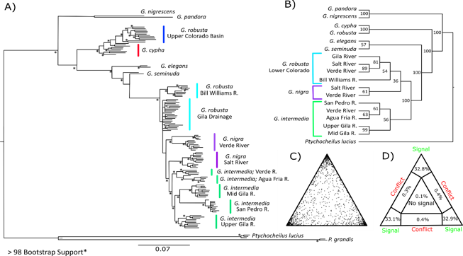

A B

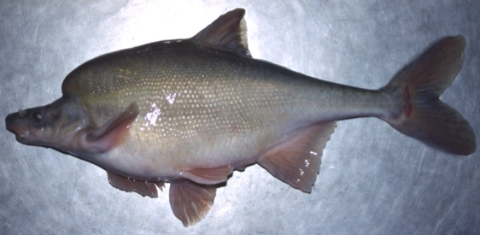

**Figure 4**. The genus *Gila*, a group of large minnows with extreme morphologies (A) such as the Humpback Chub (*G. cypha*), thought to be adaptations to turbulent currents of desert rivers. Species have been difficult to parse (B), partially due to hybridization, but this uncertainty hampers conservation. After Chafin *et al.*, unpublished.

Despite observed reticulation, two overlapping species (*G. robusta* and *G. cypha*) appear to maintain discrete morphological identities (Douglas *et al.* 1989), even in cases of sympatry (McElroy & Douglas 1995). Molecular studies failed to distinguish distinct entities (Douglas & Douglas 2007), highlighting the discrepancy with observed morphological and ecological variation. Similarly, our preliminary examinations using ddRAD data show varying levels of introgression throughout the range of overlap between species, suggesting a ‘mosaic’ hybrid zone (Figure 4b).

To retain morphological divergence despite genetic homogenization (by gene flow), some regions of the genome must be preserved by selection – inducing heterogeneity in local effective gene flow throughout the genome. To test this hypothesis and identify loci under selection presumably responsible for maintenance of species boundariesdespite widespread introgression at neutral loci, we will **combine traditional methods of assessing population structure with modeling of this ‘genomic cline’. Understanding the mechanisms that modulate diversification will aid in preserving biodiversity, as species ranges’ shift in response to climate change.**

*2.3: Modelling gene flow in White-tailed Deer to predict Chronic Wasting Disease risk and spread*

Chronic Wasting Disease (CWD) is a highly infectious prion disease that affects cervid species such as elk and deer. CWD results in neurological and physical deterioration and eventual mortality. The disease is spread directly via host transmission and indirectly through the environment. CWD was detected in a northern Arkansas elk in 2015 and has since been found in seven counties among both elk (N=7) and white-tailed deer (N=216), and **has massive economic implications for both the state of Arkansas and recreational industries associated with hunting and harvest of deer.** For example, the state of Wisconsin absorbed an estimated cost of $14.7 million per year in 2002-2003 associated with their CWD control program, with losses in hunter spending associated with CWD estimated at **$45-$72 million** **in 2003 alone** (Bishop, 2004). Arkansas has already established an 11-county CWD Management Zone, enforcing regulatory actions aimed at reducing spread (Figure 5).

A B

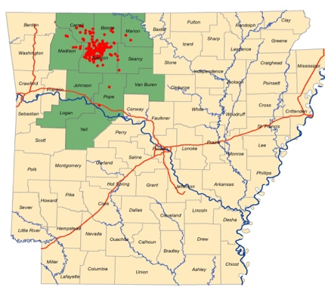

**Figure 5**. Chronic wasting disease in Arkansas (A) including the current extend of the management zone in green, with positive testing individuals shown in red. From McDill et al (unpublished). (B) shows a CWD-affected individual on the right, and healthy deer on the left. Courtesy of Wisconsin DNR.

**The Arkansas Game and Fish Commission has teamed up with the Douglas Lab at the University of Arkansas to determine the fine-scale population structure of Arkansas’ deer herd to monitor the movement of CWD across the state.** The identification of genetic variation at the nucleotide level infers population structure that can then be used to identify dispersal patterns that may either facilitate or inhibit gene flow- thereby informating most probable routes of spread and helping to direct surveillance efforts (Blanchong et al 2008). The utilization of next-generation sequencing methods and a high-performance computing bioinformatics pipeline are required for the analysis. Ultimately, an understanding of possible genetic barriers or corridors can inform management decisions concerning the patterns of disease spread across the landscape, and will contribute to the growing and ongoing CWD management by the State of Arkansas.

*2.4: Inferring genetic relatedness to bookmark spawning-site fidelity of Mahseer in Himalayan Bhutan*

The Kingdom of Bhutan is a small country in the Himalayas of central Asia with a landscape defined by steep elevation gradients, making it particularly vulnerable to effects of climate change. Bhutan has dedicated >60% of its land to conservation, but its native fishes are enigmatic, and their distributions and conservation status virtually unknown. However, conservation interests conflict with the **economic potential of hydropower dams**- as these are a boon to the economy but threaten fishes such as the Golden Mahseer (Figure 6), both a conservation icon and also having strong cultural significance for Himalayan Buddhism.

Recent collaborative work with the Royal Government of Bhutan, its Ministry of Agriculture and Forests, World Wildlife Fund-Bhutan, and the Fisheries Conservation Foundation, have radio-tagged adult Golden Mahseer (*Tor putatoria*) to study movements in these large-river fishes. Initial data suggest extensive, post-monsoonal migrations with spawning occurring in smaller tributaries. Our genetic analysis complements the tracking data and examines fine-scale population structure in Golden Mahseer in Bhutan. Here, we attempt to assess relatedness among adult individuals in the larger low-elevation reaches with juvelines caught in smaller high-elevation stream in order to discover if fishes migrate into specific tributaries for spawning- much like Pacific Salmon of the Northwest Unites States. These results provide an important baseline to **sustainably develop hydropower for the economic benefit of the Bhutanese people**, while at the same time assuring that relevant data are available to make sound management decisions to **assure long-term conservation of Bhutan’s native fishes**.

A B

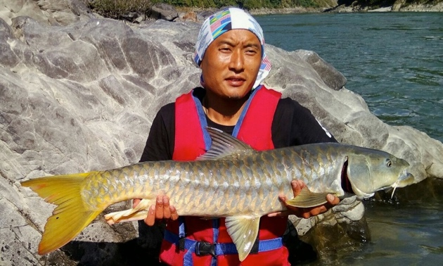 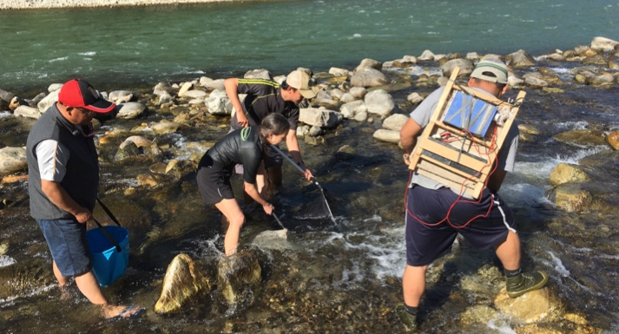

**Figure 6**. Adult Golden Mahseer (A) are caught using angling methods before non-invasive tissue samples are collected (fin clips); while juveniles in high-elevation headwaters are collected using seine nets and non-lethal electroshocking- here showing PI Marlis Douglas and Bhutanese collaborators (B)

*2.5: Factors underlying species diversification in Ozark fishes*

The purpose of this project is to explore the relationship between micro- and macro-evolutionary processes by measuring genetic divergence among fish populations within hierarchical stream networks. An obvious question related to macro-evolutionary processes is **why do some clades have more species than others?** One hypothesis is traits specific to a clade play a part in determining how specious a clade becomes—for example, traits related to dispersal ability, niche breadth, and spatial distribution. The first objective of this project is to determine the variability in such traits and their ability to explain variation in geneflow and genetic divergence among fish populations representing several of the major North American clades. The second objective is to relate this variability in traits and geneflow to phylogenetic patterns of species diversification rates.

In focusing on fishes of the Ozark region, we can also apply coalescent species delimitation and analyses of genetic connectivity for **numerous species protected under the Endangered Species Act**, and species of greatest conservation need as specified under the State of Arkansas Wildlife Action Plan, particularly many species of narrowly endemic darter (Figure 7): *Etheostoma fragi* (Strawberry River Darter); *Etheostoma mooerei* (Yellowcheek Darter), *Etheostoma uniporum* (Current Darter)*,* and *Percina uranidea* (Stargazing Darter). Understanding the evolutionary processes underlying species diversification has critical implications for conservation, in that it may allow organism-specific conservation prioritization by allowing categorization not only by established taxonomy, but by ‘evolutionary potential’.

A B C

  

**Figure 7**. Darter species (A,B) are often tied to inherently ephemeral headwater streams, and due to their often narrow and fragmentary distributions are particularly vulnerable to habitat degredation- such as the federally endangered Yellowcheek Darter (C), which has a range divided by the Greers Ferry reservoir in Arkansas.

*2.6: Genomic signatures of adaptive life history shift in a host-specific parasitic tapeworm*

The tapeworm *Nippotaenia mogurndae* (Cestoda: Nippotaeniidae) is co-invasive throughout Russia/ Eastern Europe with its specific host, the Amur sleeper (Actinopterygii: Odontobutidae; *Perccottus glenii*; Kvach et al 2013). The persistence of *N. morgurndae* requires the acquisition of (potentially) novel intermediate hosts within the invasive range so as to facilitate its transmission to the final host (*P. glenii*; Reshetnikov et al 2011). A potential shift in intermediate host underscores the selective pressures placed on the invasive tapeworm in that metabolic pathways of the adult stage are often specialized for their specific hosts. Thus, questions regarding the invasion ecology of *N. morgurndae* focus on the potential for a niche shift with regards to its intermediate host, as well as the genetic underpinnings of specificity in the final host- both objectives having **implications for host-parasite biology as well as biomedical study of human pathogens**, in that gene family expansions and alterations in this complex may inform genes involved more generally in host-specificity.

We plan to address both objectives using *de novo* whole genomics. To initiate this process, we employed a hybrid approach using Illumina© (=short-read) and PacBio© (=long-read) technologies that were used in the *de novo* assembly of the nippotaeniid genome. We plan to combine a **comparative genomic approach** to investigate gene-level evolution by comparing the *Nippotaenia* genome to the 14 other available cestode genome assemblies, as well as with population-level resequencing to focus on nucleotide-level changes within populations from the invasive and native ranges. *Nippotaenia mogurndae* is also a basal relative of the Cyclophyllidea (Hoberg et al 1998), a clade including tapeworms infecting both humans and domestic animals (e.g. *Taenia solium*). **Thus, our genome provides a necessary historic baseline from which the anthropogenic pathogenicity of Cyclophyllidean tapeworms can be compared and contrasted**- and the only genomic investigation to date for the order *Nippotaeniidia*.

1. **Resource Usage Plan**

*3.1: Analytical approaches to be employed*

We here outline briefly the usage and expected runtimes for most softwares/ analyses to be utilized for the objectives listed in Section 2. Because many methods overlap between our objectives, the focus in this section is on individual methods, and we describe how these contribute to per-objective resource usage in Section 3.2 below. Detailed information on how we came up with these SU estimates are provided in the separate Code Performance and Scaling document. Note that most of our analyses require XXL Jetstream VMs due to memory limitations, thus incurring greater SU consumption per compute-hour. All softwares are open-source and publicly available, and in some cases have been modified by lab members to optimize efficiency or enable application to largescale datasets.

Admixture : A tool for maximum likelihood inference of population structure and admixture (Alexander et al 2009). We use this program in conjunction with the program Structure to infer subdivision within species at the population level. Walltimes are expected to average 24 hours (1,056 SUs), with a maximum observed runtime of 4 days (4,224 SUs) depending on dataset size, model complexity, and number of MCMC iterations.

BayesAss : The program BayesAss is used to infer contemporary migration rates (Wilson and Rannala, 2003), a critical step in inferring Management Units, a conservation metric for subdividing endangered species into demographic units for independent conservation. Lab member Steven Mussmann has written a version of this software which accommodates large datasets, previously impossible (see github.com/BayesAss3-SNPs). Models are expected to run ~100 hours linearly (=100 SUs).

BGC : Bayesian analysis of genomic clines. This program uses MCMC to and Bayesian inference to quantify introgression at many loci while incorporating genotype uncertainty and sequencing errors (Gompert and Buerkle 2011). Average runtimes running across 44 cores are expected to average 2 days (2,112 SUs)

BFD : We perform species delimitation using BEAST/SNAPP in a multispecies coalescent framework (Leache et al 2014), and compare marginal likelihood of models using Bayes Factors in order to determine optimal models of ‘species splitting’. Tracking memory usage empirically, memory requirement *per thread* varied from 8.9 to 10.1 GB. Runtimes range from 150 hours (=6,600 SUs) to 46 days as our maximum observed runtime (=48,840 SUs)

BUCKy : A phylogenetics package for building species trees using Bayesian Concordance Analysis ot maximize concordance among genomic loci originally published by Larget et al (2010). Lab member Tyler Chafin has written a novel parallel implementation using OpenMPI (located at github.com/tkchafin/mpi-bucky) which provides a 6.5X speedup for a standard analysis. A full-length run is budgeted at 18,040 SUs.

MAKER : Software pipeline for genome annotation and *ab initio* gene prediction using Hidden Markov Models and various types of gene evidence (e.g. mRNAseq; Cantarel et al 2008). Runs are expected to take ~24 hours (=1,056 SUs) for our genome size.

Phylogenetics: Numerous phylogenetics packages will be employed, including ASTRAL, BEAST, BEST, ExaBayes, ExaML, IQTree, PAUP*, PoMo, RAxML, and SVDQuartets. Average runtimes for a dataset with ~20,000 loci and ~400 individuals range from 1-6 days (7,392 SUs max) on the shorter end (e.g. RAxML, BEAST) and ~30 days (31,680 SUs) for longer-running softwares (e.g. ExaBayes, SVDQuartets).

pyRAD : The primary processing and analysis pipeline employed for quality trimming, assembly, and alignment of RAD and ddRAD datasets (Eaton 2013). Expected walltimes when parallelized across 44 CPUs average 20 hours (=880 SUs), with the maximum observed walltime being 5 days (=5,280 SUs)

SPAdes: *De novo* genome assembler.Although memory-intensive with larger (non-prokaryote genomes), we have found this *de novo* assembler to produce by far the highest quality assemblies for our work with *Nippotaenia mogurndae* compared to other assemblers we have tried (Platanus, Ray, SOAPdenovo, Velvet). Runtimes exploring parameter values are expected to run 100 hours (=4,400 SUs) based on prior experience.

Structure : Bayesian program utilizing K-means clustering and MCMC to detect and assign individuals to genotypic clusters corresponding to populations. Used for inferring population structure, identifying putative hybrid or admized individuals, and inferring admixture among populations or species (Pritchard et al 2000). Observed runtime for simple models (K=2) of 70 hours per replicate (=80 SUs), and >200 hours for moderately complex models with a dataset in the thousands of loci and hundreds of individuals. Walltime per replicate scales exponentially with model complexity, and linearly with dataset size. A common framework is to run 10-20 replicates, with model complexities ranging from simple to very complex (high K values)

*3.2: Summary of resources requested per objective*

Total resource usage is summarized in Table 3 and outlines per objective (see Section 2) below:

1. *Biodiversity delimitation and ‘the species conundrum’: quantifying genetic delineators*

Previous work with *Rhinichthys* during the Jan-Dec 2017 XRAC period identified the need for increased sampling (see Progress Report). As such, we propose the following additional analyses for the Jan-Dec 2018 period:

* 10 models of species delimitation in BFD to accommodate 2017 sampling of new putative subspecies. Assuming an average runtime of 500 hours (=22,000), we request 220,000 SUs
* We also would like to budget phylogenetic analyses in the packages ASTRAL, ExaBayes, ExaML, PoMo, and RAxML, for a total estimated 50,000 SUs

1. *Introgression in endangered fishes and species boundary uncertainty*

New samples acquired during the 2017 sampling period necessitate more compute time for the 2018 allocation period, thus we request:

* 20 runs of the software processing pipeline pyRAD to optimize parameters such as minimum coverage, allowed missing data, and clustering thresholds for alignment/ assembly. 17,600 SUs
* 10 replicates of the program Structure for K-values ranging from 1-6. Assuming an average runtime of 80 hours per replicate, the total required is 4,800 SUs
* 10 runs of the program Admixture for validating Structure results using an alternative methodology, 5,000 SUs
* 5 runs of the program BGC, allowing for exploration of MCMC lengths and specification of priors, 10,560 SUs
* Phylogenetics in ExaML, ExaBayes, Maximum Parsimony in PAUP*, SVDQuartets, for a total estimated usage of 120,000 SUs

1. *Modelling gene flow in White-tailed Deer to predict Chronic Wasting Disease risk and spread*

As a part of this new collaboration with Arkansas Game and Fish Department, we expect to conduct exploratory analyses, as well as provide results for the 2017 sampling efforts. We anticipate new sampling for 2018 which will require additional analysis.

* 5 runs of the program pyRAD (4,400)
* 20 replicates of the program Structure for K-values ranging from 1-20. We assume SU consumption averaging 150 SUs per replicate, thus requiring 60,000 SUs
* 10 runs of the program Admixture for validating Structure results using an alternative methodology, 5,000 SUs

1. *Inferring genetic relatedness to bookmark spawning-site fidelity of Mahseer in Himalayan*

This new work in collaboration with researchers from the Illinois Natural History Survey, World Wildlife Fund, and Bhutanese government Department of Forest and Park Services will also require exploratory analyses to inform sampling efforts during 2018, as well as new analyses following the 2018 field season.

* 5 runs of the program pyRAD (4,400)
* 20 replicates of the program Structure for K-values ranging from 1-20. We assume SU consumption averaging 40 SUs per replicate (this dataset is much smaller than those for objectives 2 and 3), thus requiring 16,000 SUs
* 10 runs of the program Admixture for validating Structure results using an alternative methodology, 5,000 SUs
* We also would like to budget 10,000 SUs for exploratory analyses with various software packages for assigning parentage and calculating relatedness (e.g. Colony2)

1. *Factors underlying species diversification in Ozark fishes*

In 2017 lab members Zach Zbinden and Tyler Chafin surveyed 50 sites throughout the Ozark region of Arkansas. We aim to conduct analyses across ~10 species, quantifying gene flow and levels of differentiation in relation to environmental factors and physical characteristics of those fishes, thus requiring many analyses applied separately to all 10 taxa.

* 4 pyRAD runs per taxon, = 40 total pyRAD runs (35,200)
* 40 runs of the program BayesAss per taxon (enabling numerous pairwise comparisons), = 200 total runs (40,000 SUs)

1. *Genomic signatures of adaptive life history shift in a host-specific parasitic tapeworm*

Our work assembling the initial draft genome in 2017 will be bolstered by recently acquired long-read (PacBio) and RNAseq data for scaffolding and annotation, requiring the following resources:

* 5 runs of the assembler SPAdes, for a total of 22,000
* 10 runs of the MAKER annotation pipeline, as multiple will be necessary for initial gene models, followed by re-training using initial gene models informed by other cestode cDNA libraries and subsequent re-running of MAKER (10,560)
* We would also like to budget 20,000 SUs for exploring alternative *de novo* assemblers, as well as for other incidental steps (e.g. Pilon for genome polishing, LINKS for scaffolding, Redundans for collapsing redundant contigs)

|  |  |
| --- | --- |
| **Objective** | **SUs** |
| 1 | 280,000 |
| 2 | 156,160 |
| 3 | 69,400 |
| 4 | 35,400 |
| 5 | 75,200 |
| 6 | 52,560 |
| Inc.* 10% | 65,000 |
| **Total** | **734,000†** |

**Table 1**. Summary of SUs requested by objective. *We include a 10% ‘buffer’ to allow for problems implementing codes, exploratory analyses to adjust parameterization and specification of priors (necessary for all Bayesian analyses), and general debugging. †We have also rounded the total to the nearest thousand.

1. **Resource Justification**

*4.1: MCMC and inherent walltime issues*

**Many biological applications require long run times** due to the intrinsically sequential nature of the algorithm on which they are based, **Markov Chain Monte Carlo (MCMC)**. MCMC is used in Bayesian methods to explore the parameter landscape in order to approximate a posterior probability distribution (including tree topology). This is accomplished via randomly drawing parameter values from a prior distribution and assessing the effect of this change on the overall likelihood of the model - which, using some threshold, is used to either accept or reject a change. The expectation is that the Markov Chain should most densely ‘sample’ parameter space where likelihoods are maximized - thus by sampling the MCMC state, the expectation of a statistic under some complex model can be explored. Because of this underlying model having very limited parallelizability (but see our implementation of one software in attached Code Performance and Benchmarking document), **many biological softwares have extreme walltime usage when applied to large datasets** (e.g. thousands of sequences), **thus limiting the applicability of traditional public HPC resources**.

*4.2: Coalescent species delimitation and memory limitations*

**Combining reduced-representation genomic datasets** (containing tens of thousands of loci across hundreds or thousands of individuals) **with new methods of phylogenetic inference provides an unprecedented framework for species delimitation**. Until recently, to infer the species branching pattern, delimitation methods relied on the ability to infer gene trees to characterize variation in the coalescent process (Fujita *et al.* 2012). This method is not tractable at the shallow phylogenetic scales of conservation studies (as outlined in Section 2), where individual loci contain very little information - thus independently inferred gene trees are unresolved.

Recent advances allow species tree inference directly from SNP datasets, facilitating simultaneous integration over gene trees and species trees. SNAPP, the underlying phylogenetic method to Bayes Factor Delimitation, implements a multispecies coalescent model in this way, without explicitly requiring the *a priori* definition of gene tree posterior distributions (Bryant *et al.* 2012). Bayes Factor Delimitation combines this approach with explicit model testing using Bayes factors as a metric for comparing marginal likelihood estimates for candidate delimitation models (Grummer *et al.* 2014; Leache *et al.* 2014), including normalization via a proportionality constant, to make models of varying numbers of parameters to be directly comparable.

However, in addition to employing an inherently sequential algorithm, thus requiring long runtimes (sometimes over a month), **model based species delimitation also required substantially high memory resources**. Tracking memory usage empirically, memory requirement *per thread* varied from 8.9 to 10.1 GB. Running these models requires large memory resources such as the ‘XXL’ instance size offered by Jetstream (44 cores, 140 GB memory). See Code Performance and Benchmarking.

1. **Resource Appropriateness**

**The Jetstream cloud system presents a unique opportunity to promote collaboration between researchers of different disciplines to address these contemporary objectives that require both bioinformatics and organismal expertise.**

In particular, the VM-based resource-use can allow one user to configure an instance with software and even a specific OS architecture, that can be imaged for additional deployment on an arbitrary number of instances, accessible by other research group members or collaborators without any additional configuration. Thus, many projects can be progressed in parallel with diminishing up-front configuration time after the initial set up, and bioinformatics support members can access all instances.

**Our lab was among the first to harness the Jetstream system during the Early Operations phase to produce publishable science, and we plan to extend and expand these efforts if the present allocation renewal is granted.** Due to the flexibility and usability of Jetstream through the Atmosphere interface, a single lab member can configure resources for the entire group.

Additionally, the flexibility of VM-based resource use allows both long-running, sequential but non-scalable codes (e.g. Structure) to run on smaller VM sizes, with scalable but memory-intensive codes can occupy XL or XXL VMs. The ease of use, flexibility of VMs, imaging-system, and hardware of individual nodes on Jetstream place it uniquely in the ‘goldilocks zone’ for labs (and disciplines) like ours which are excluded and have very limited use for the rigidity and limitations of public traditional HPC- as far as we are aware, **there are no other practical or publicly-accessible criteria that satisfy all criteria (e.g. I/O speed, memory, cores per node, walltime, flexibility).**

1. **Availability of Other HPC Resources**

The Arkansas High Performance Computing Center operates and maintains two traditional HPC systems, however hardware of individual nodes, restrictions of the public queueing system, and failing hardware all hinder significant Douglas Lab presence on those systems.

The RAZOR cluster consists primarly of 16-core, 32 GB nodes, with a very small number of higher-memory resources. TRESTLES consists of 32-core AMD nodes with 64GB of memory. Many of our softwares (e.g. BFD) require larger memory- for example, where we can run 10 threads of a BFD analysis on a single XXL Jetstream VM instance, we could only run 2-3 on a RAZOR node, extending a sometimes month-long analyses by 3-5X length, differences in processor speeds notwithstanding. The primary issue, however, is that public queues on AHPCC systems are limited to 30 minutes, 6 hours, and 72 hours- a common scheme for traditional HPC yet **at the maximum barely accommodating the shortest-running of our applications**. This critical limitation likely speaks to the limited adoption of traditional HPC resources in XSEDE by organismal biologists.